**LAB EXERCISE-2**

TERRAFORM AWS PROVIDER AND IAM USER SETTING

* Create a new folder in your local for your terraform configuration
* Open this folder in VS code and make a file main.tf and place this configuration in this main.tf file
* terraform {
* required_providers {
* aws = {
* source = "hashicorp/aws"
* version = "5.31.0"
* }
* }
* }

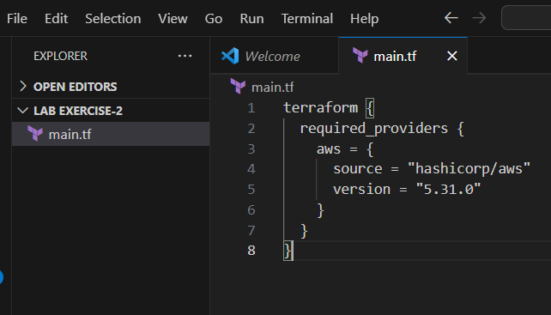

* AWS Credentials: Ensure you have AWS credentials (Access Key ID and Secret Access Key) configured. You can set them up using the AWS CLI or by setting environment variables.

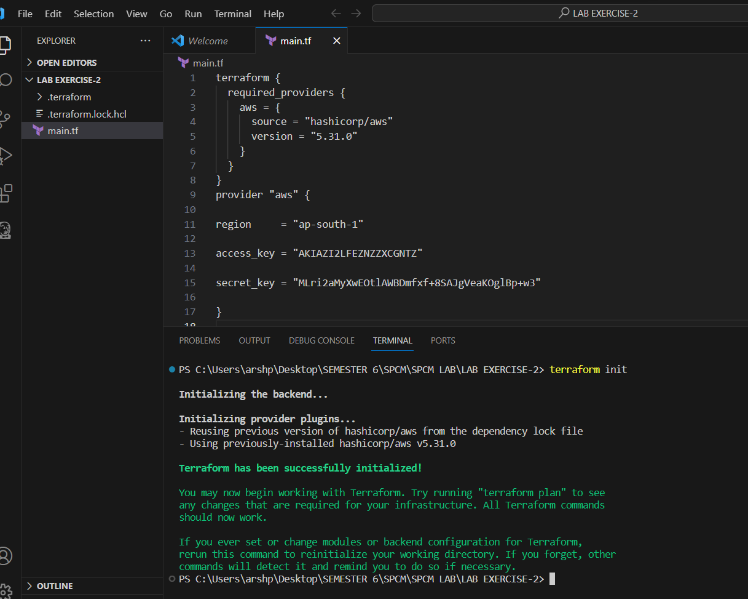

* Initialize this directory to terraform

